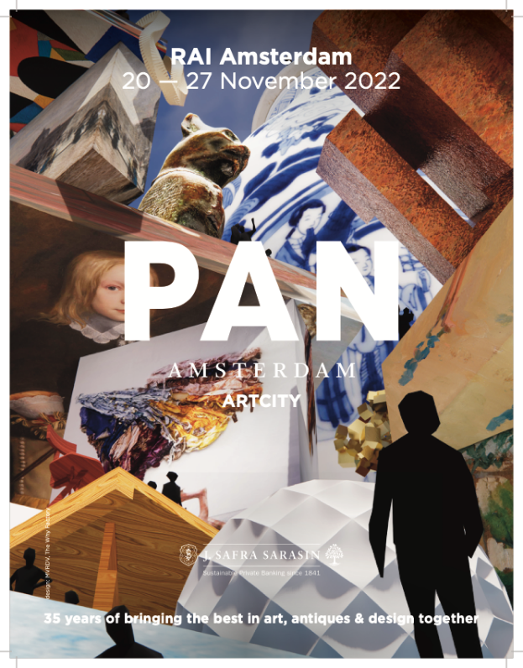

Sunday 20th to Sunday 27th November 2022 at RAI Amsterdam
PAN AMSTERDAM: 35 years of bringing the best in art, antiques & design together
PAN Amsterdam will celebrate its 35th anniversary as the Netherlands’ leading art, antiques and design fair from Sunday 20th to Sunday 27th November. Showcasing 125 art & antique dealers and galleries ranging from familiar PAN favourites to exciting newcomers the fair will offer a wide and diverse offering of art, antiques and design from home and abroad.

125 art & antique dealers and galleries
PAN Amsterdam 2022 has a range of 125 gallerists, antique dealers and art dealers with an assortment of paintings, antiques, modern and contemporary art to jewelry, photography, design furniture and objects from ancient and distant cultures. The broad and eclectic mix of exhibitors ranges from leading Old Master specialists such as the Rafael Valls Gallery and Weiss Gallery from London, and the Koetser Gallery from Zürich alongside contemporary Dutch furniture designer Piet Hein Eek. Antiques from the distinguished Limburg Antiquairs, art deco silver from Rondom 1920 and exquisite 20th century jewellery from Epoque Fine Jewels feature alongside POP, ZERO & Nouveau Realisme from the Borzo Gallery and The Mayor Gallery.
The newcomers’ pavilion, Walls & Cabinets, welcomes galleries Martin van Zomeren, Kers Gallery and The Ravenstijn Gallery, Den Otter Fine Art, Joost van den Bergh from London and Duende Art Projects from Antwerp as first timers on the fair.

PAN is back en better than ever
Mark Grol, Managing Director of the PAN: “PAN Amsterdam is the Netherland's leading fair in art, antiques and design. Every year, more than 35,000 art lovers are inspired and tempted by the many thousands of works of art on show. Whether your interest lies in classical antiquity, old masters, photography, contemporary art, antiques, designer furniture or decorative objects, PAN is the perfect place to compare art, gather information and make surprising discoveries. Each object is vetted by independent experts for quality, authenticity and condition before the fair opens, giving you the assurance so you can buy with confidence.
PAN Amsterdam 2022 is back and better than ever, after the last two turbulent years. With 16 exhibitors and galleries from abroad and 15 more exhibitors compared to last year – when we had amazingly high visitor numbers and excellent sales – nearly all regular exhibitors have chosen to return and we have an exciting line up of new exhibitors. This, along with an exciting programme of events should make this anniversary edition of PAN Amsterdam one to remember. For the expected 35,000 plus visitors we are hoping this year’s PAN will offer a unforgettable spectacle or an actual ‘ArtCity’ as the architect Winy Maas has depicted in our iconic campaign image for this year.

PAN campaign image 2022 by Winy Maas: ‘ArtCity. Everything is Art’
Each year the PAN asks a leading figure in the art world to design a campaign image to be used for marketing the fair. This year Winy Maas, architect and co-founder of MVRDV, has designed PAN’s image for 2022: “ArtCity. Everything is Art”. Inspired by the idea of regarding anything in the city as an object of art. “Whether it’s a bridge, a building, a park or a child’s chalk drawing on the pavement: everything has artistic value”. In the campaign image Winy depicts a city where every nook and cranny is piled high with art objects, “spaces where everyone and their ideas are welcome: an inclusive city brimming with art”.

Daily talks on the PAN Podium
PAN Podium offers the visitors of PAN Amsterdam a varied program full of inspiring talks and interactive presentations. The many diverse art disciplines, the art market and the fun of collecting are central to this. This year, the programming per day will be centered around a different theme, from museums to young collectors and from jewelery to old masters. In the daily talks designer Richard Hutten will highlight his work, artist Jan Dirk van den Burg will give a performance and porcelain, museums and sustainable design will be in the spotlight. All fair visitors are welcome to this daily changing programme.

New: PAN Education App
New this year is the PAN Education App. This app can be used during the exhibition days. Anyone can download this app and is intended to send visitors – of all ages – on a journey of discovery. The app shows three routes with different themes, such as: Meesterlijk Material, Other Views and Panimals (for the young visitor). Via these routes you look for objects that play a role within the relevant theme. In this way, young and old are introduced to the world that is hidden behind the objects on display at the fair.

35 year anniversary PAN Amsterdam
In 1987 six leading Dutch antiques experts, art dealers and enterprising private art lovers took the initiative to launch PAN Amsterdam giving Dutch dealers a national showcase. Since then, PAN has evolved and become the Netherlands’ leading national art fair, where art, antiques and design are presented by more than 125 art and antique dealers and gallery owners, primarily from the Netherlands. Each year 250,000 invitations are sent, and approximately 35,000 visitors come to the fair to see its broad range of top international art, which covers five millennia of art history. PAN Amsterdam has earned widespread praise for the quality of the objects on sale. This quality is secured by means of a meticulous vetting process. Eighty independent specialist vetting experts, organised in committees, appraise the authenticity, quality and condition of all the objects before the fair.

www.pan.nl
For tickets and more information about all exhibitors, the artists, the objects and the daily program and talks on the PAN Podium: visit www.pan.nl
______________________________________________________________________________________
Note for the editors /not for publication:
If you require more information/images, please do send an email to the Press & PR manager of PAN Amsterdam: Ingrid Looijmans, ingrid.looijmans@pan.nl or call +31 6 54680742.

